Treasurer’s Report for financial year 2025/2026 prepared for the
Aotearoa College of Diabetes Nurses (NZNO) Annual General Meeting

Bryan Gibbison, 28 April 2026

This report for the financial year from 1 April 2025 to 31 March 2026, is based on unaudited financial data from NZNO.

The 2025/26 financial year finished on a positive note for the college. Overall income for the year was $20,417.49 with total expenses of $17,778.82, resulting in a net surplus of $2,638.69. This compares favourably to a deficit of $769.91 in the 2024/25 financial year.

Income:

 | 2025/26 | 2024/25 (rounded)
NZNO core funding | $11,732.00 | $11,478.00
Grants and Sponsorship | $4,329.36 | $3,652.00
Registration fees | $2,549.00
Interest | $1,288.99 | $2,315.00
Total income | $20,417.49 | $18,315

Expenses:

 | 2025/26 | 2024/25(rounded)
Grants* | $2,584.80 | $5,105
Honoraria | $2,984.72 | $2985
Donations and koha** | $1,868.23 | $350
Flights | $3,371.51 | $3,173
Meeting expenses (taxi’s, parking, km) | $2,743.18 | $$2.059
Accommodation & meals | $3,154.69 | $3,575
IT subscriptions | $562.35 | $534
Withholding tax | $360.88 | $648
Total expenses | $17,778.82 | $19,085

Notes:
- *Grants are lower than previous years as the PG study grant was not awarded during the financial year
- **Donations and koha are higher than previously as it includes koha to the accreditation assessors and moderator following the disestablishment of the accreditation programme

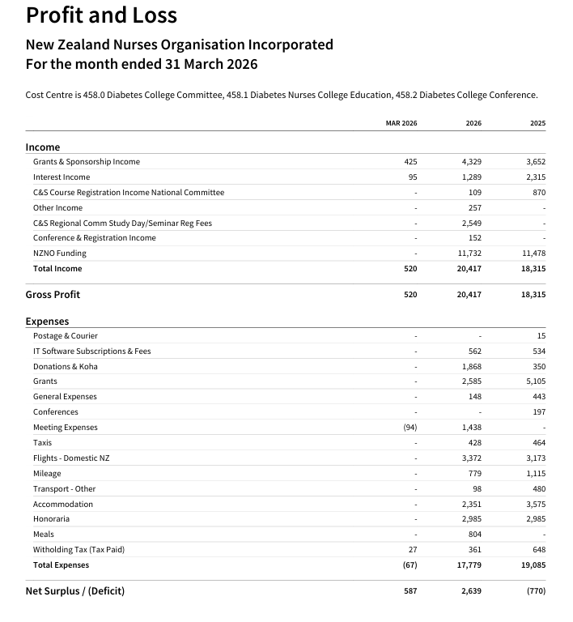

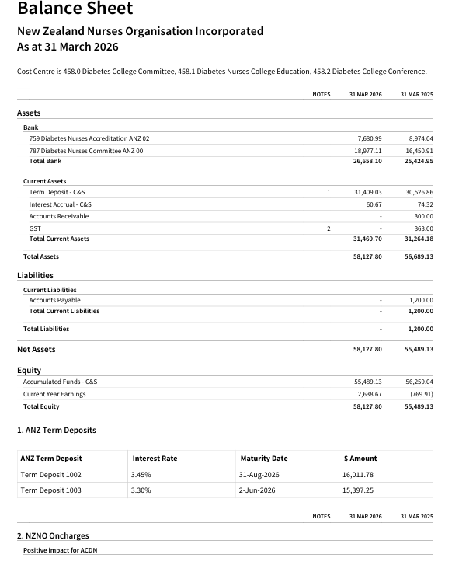

Balance Sheet

Assets:
Bank: National Committee Account (00): $18,977.11
Accreditation Account (02): $7,680.99
Total: $26,658.10 (2024 = $25,424.95)

Term Deposits: $16,011.78 invested for 6 months at 3.45%
$15,397.25 invested for 3 months at 3.30%
Interest accrual: $60.67
Total $31,469.70 (2024 = $31,264.18)

Total Assets: $58,127.80 v $56,689.13

Liabilities: Nil
- - $1200.00
Net assets: $58,127.80 v $55,489.13

Equity:
 | 2026 | 2025
Accumulated funds | $55,489.13 (balance from 31/3/25) | $56,259.04
Current year surplus/(deficit) | $2,638.67 | ($769.91)
Total equity | $58,127.80 | $55,489.13

Discussion:
The financial report shows an improvement from the previous year.
- We have run a successful study day that generated income
- Our grants and sponsorship have continued
- There has been a small increase in core funding

We are in a positive balance as at the end of the financial year primarily due to not being able to award the PG study grant in the last financial year. The successful applicant withdrew their application following the January weather events which badly affected their region and they could no longer take up study. Taking this into consideration, there will be two PG study grants awarded in the 2026/27 financial year.

To give greater flexibility with the National Committee account it is proposed that the balance from the Accreditation account be transferred to the National Committee account. This will mean we are less likely to run a deficit budget in the future.

